To run app

1. Make a github account and the click on the link below

[code.cs50.io](https://code.cs50.io/)

2)click on log in via github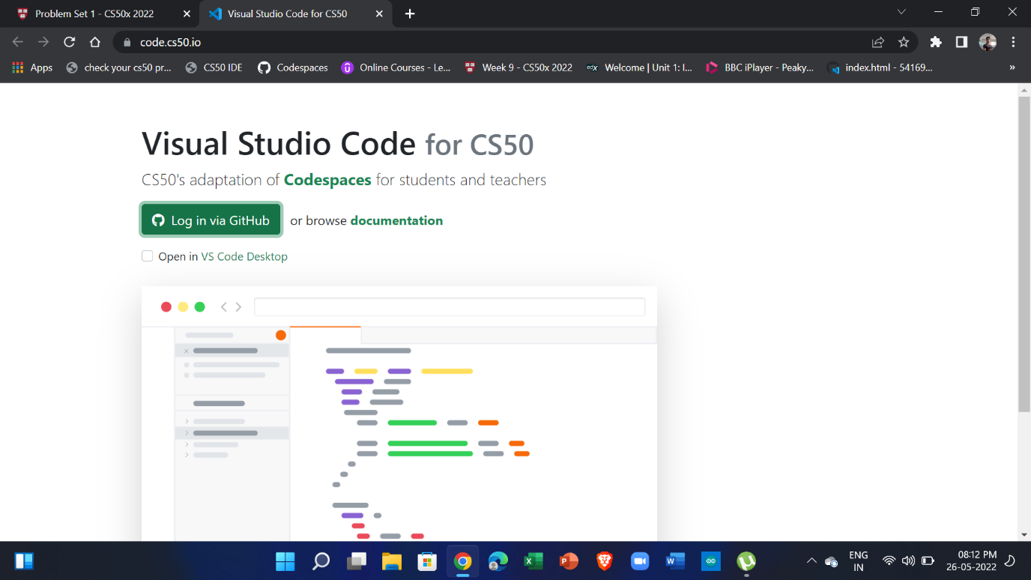

3) authorize 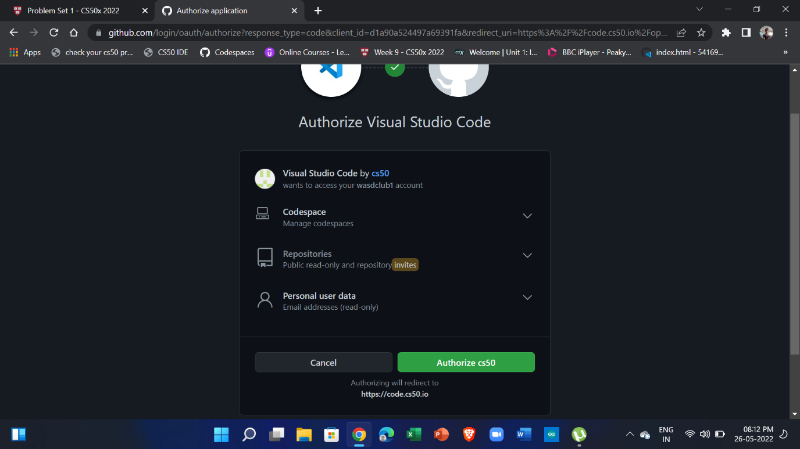

4) wait for setup to finish 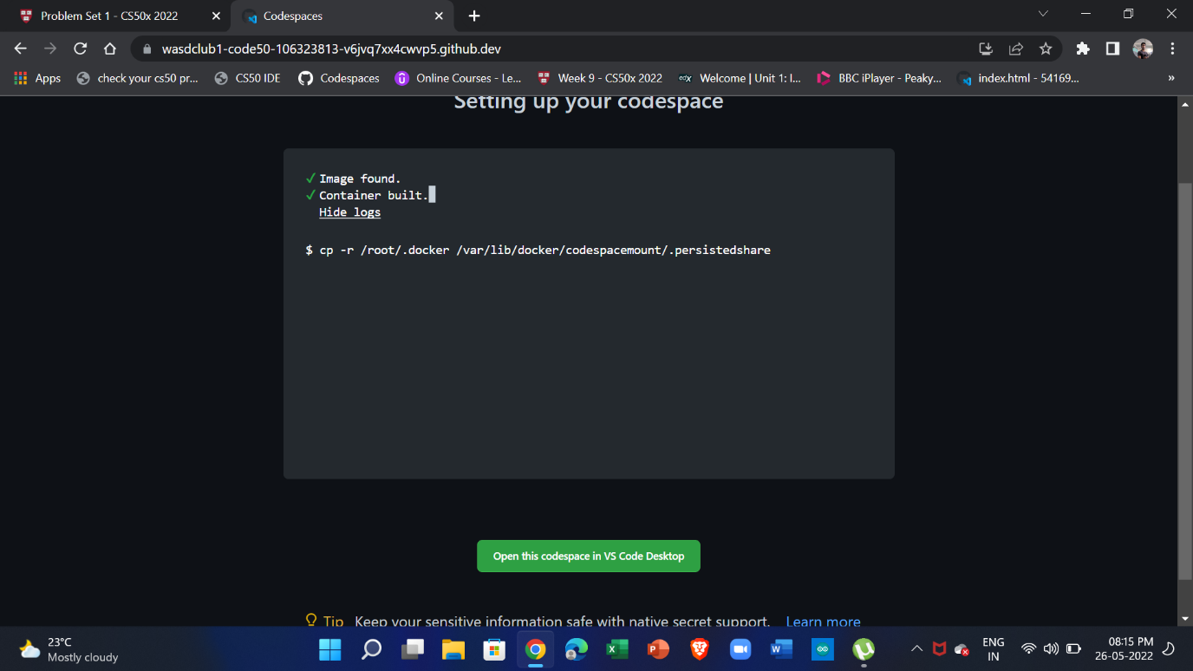

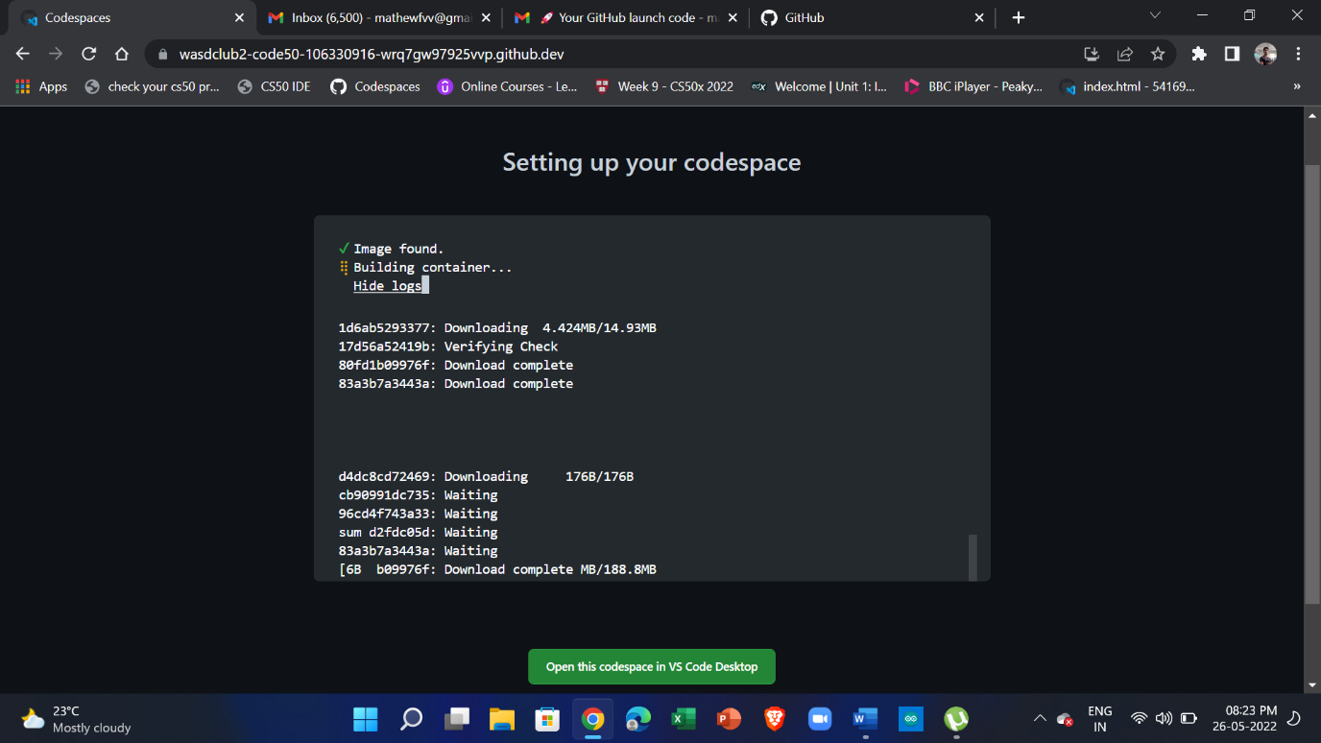

Can also use

<https://github.com/codespaces>

to view created code space

5) code space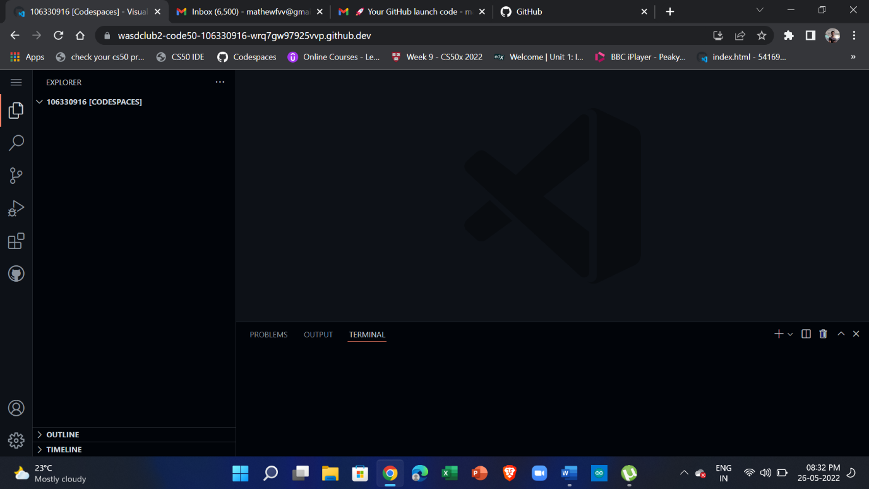

6)

Extract fridge

FYP code\FYP code\web

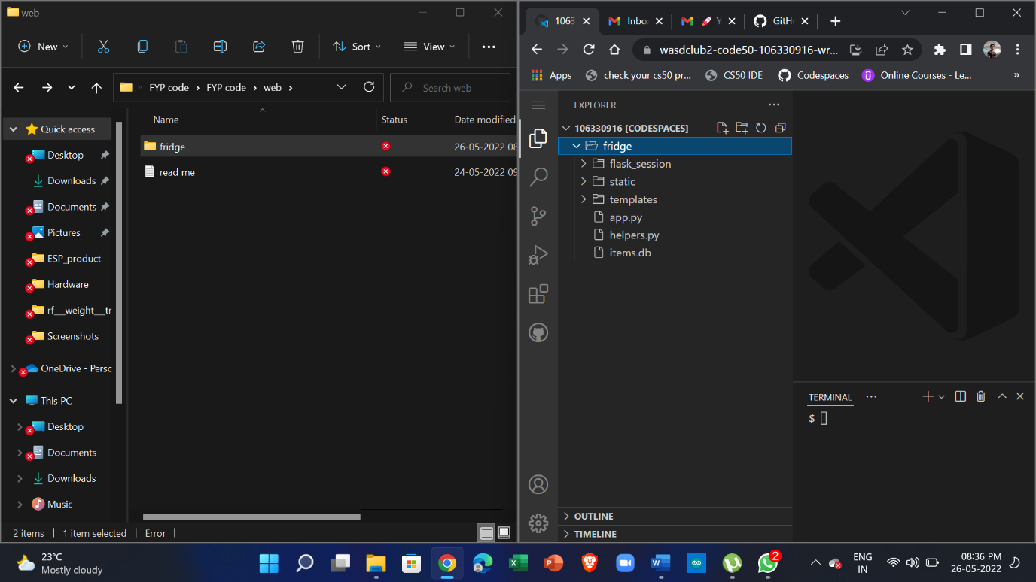

7)

In terminal

cd fridge

flask run

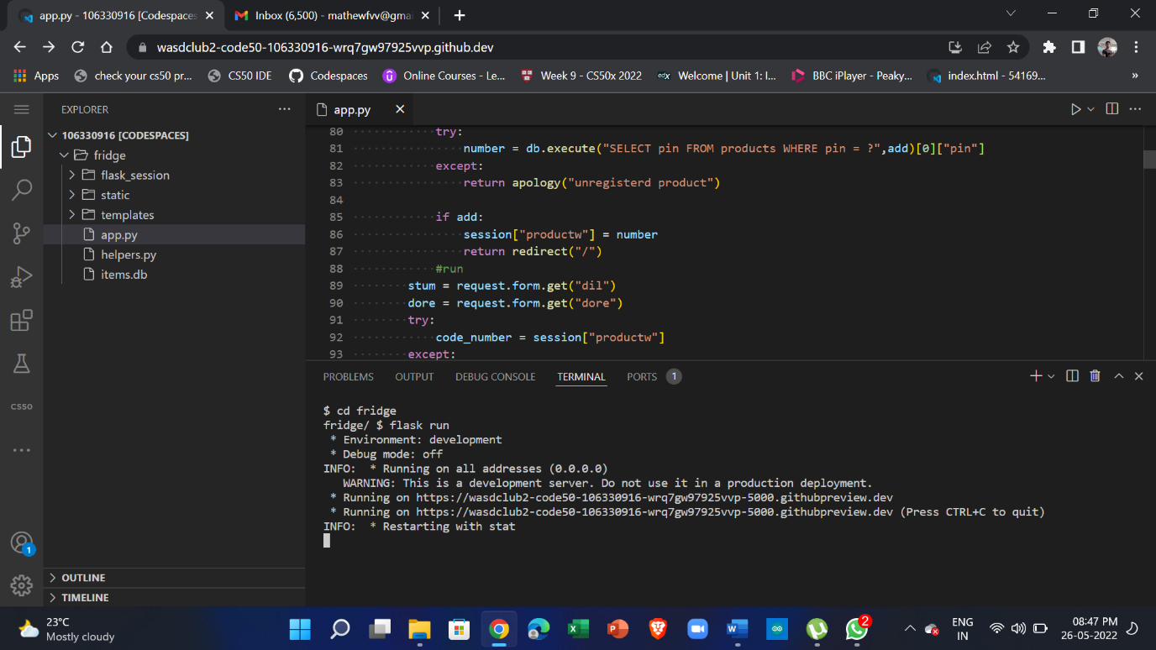

8)

Click on link and Ctrl + left click will start the application

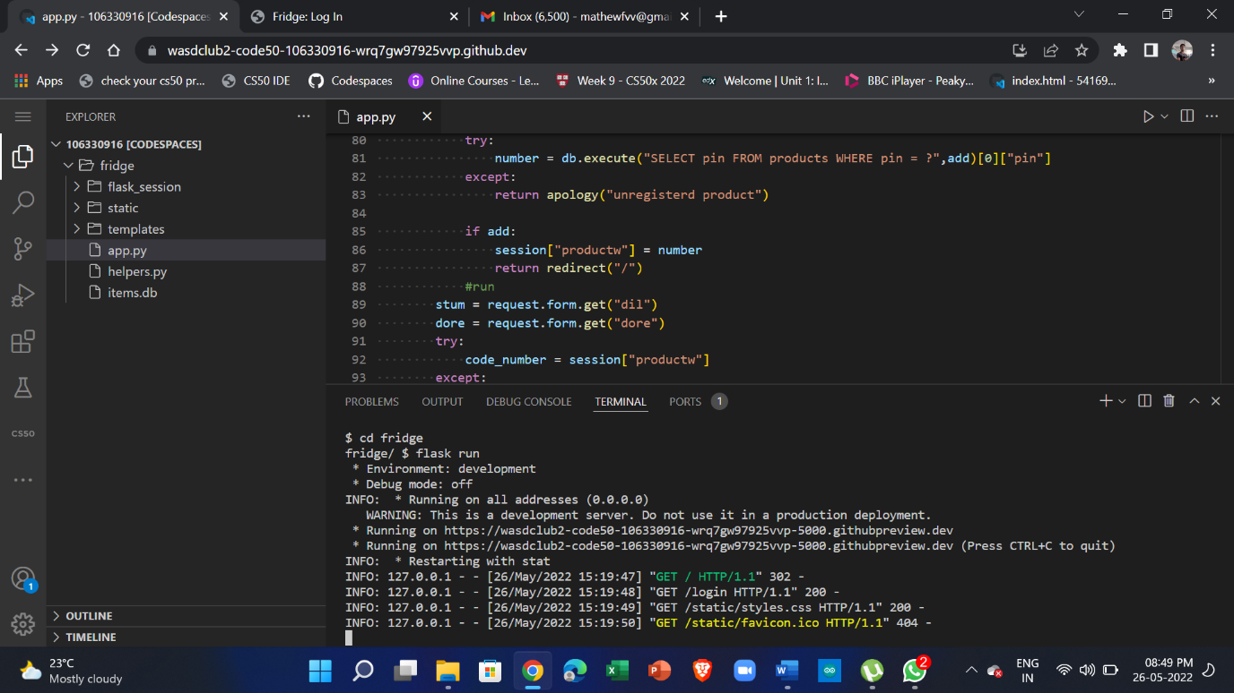

9)

In terminal space go to PORTS > port 5000 is where the app is running > make public then setup iot device to send data

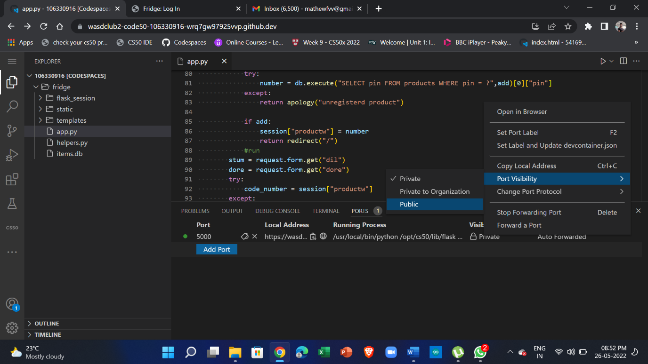

10)

The app may not launch right away so try right clicking on 5000 port and open in editor

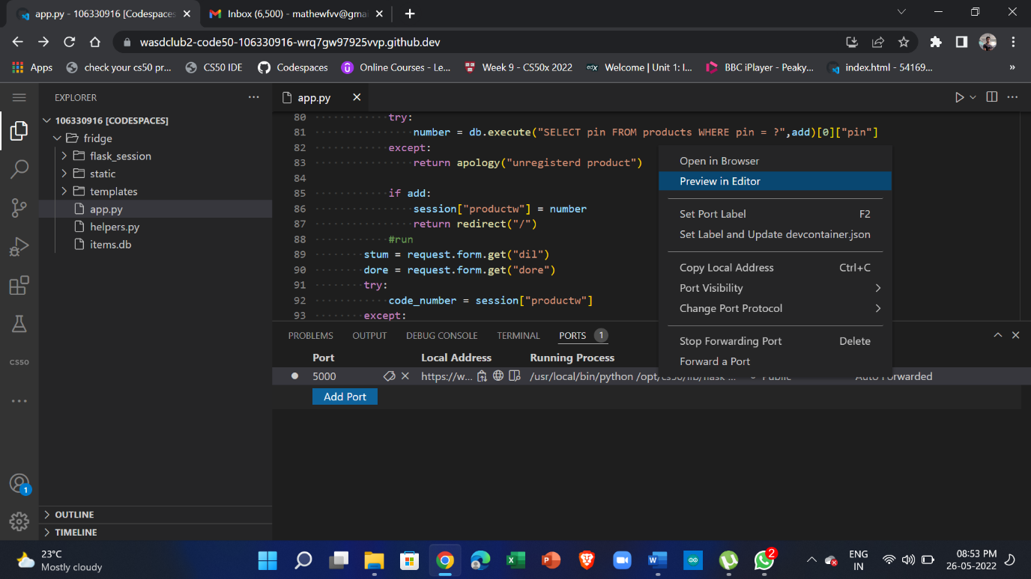

Repeat till the log-in page is shown

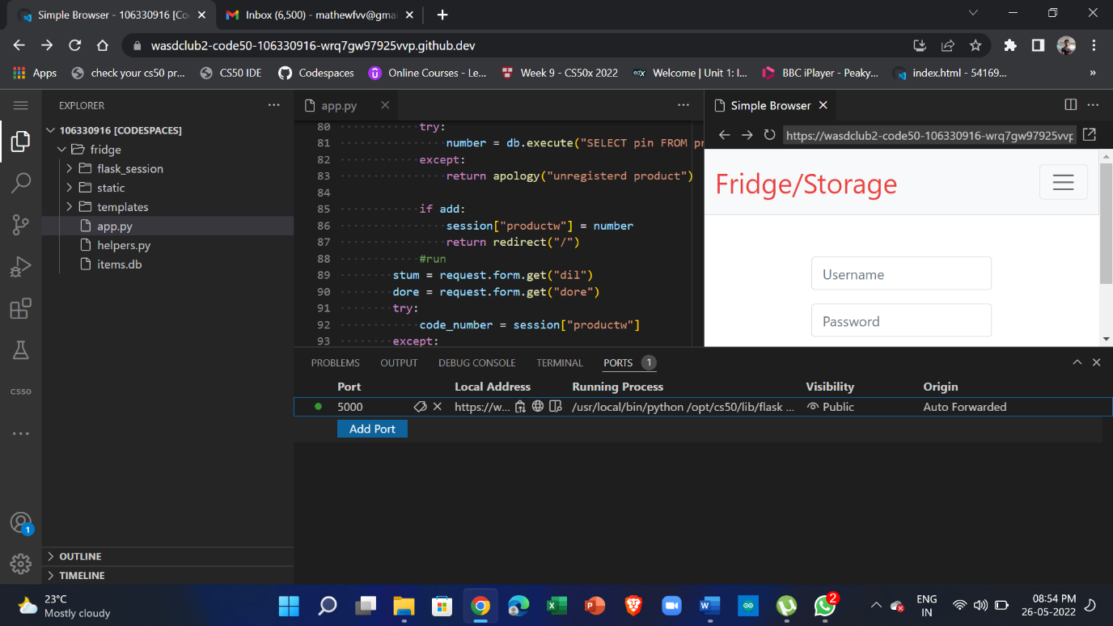

Now you can open the port on any browser

Copy or share link on any device to view page

Ctrl+ c to shut server down